**Multi-Model Approach to Recommend**

**Personalized Music Playlist**

**TMP – 2023 – 24 - 065**

**Status Document – 1**

Fernando M.P.T.K. – IT20610852

**Supervised by –** Mr. Thusithanjana Thilakarathne

B.Sc. (Hons) Degree in Information Technology

Department of Software Engineering

**Sri Lanka Institute of Information Technology**

**Sri Lanka**

December 2023

# Table of content

Table of Contents

Table of content 2

Introduction 4

Work Breakdown Chart 5

Gantt Chart 6

Finding Supervisors and Selecting the research topic 7

Data Gathering and Research 8

8

MS Teams Group Creation and continuous meetings 10

Active with a OneDrive (Cloud) Folder for easy collaboration 13

Active with a WhatsApp Group for the Team collaboration 14

14

Maintaining a logbook 15

Progress so far…. 16

16

# Introduction

Music recommender systems play a crucial role in assisting users to discover new music that aligns with their preferences, enhancing their overall music consumption experiences. Existing music recommendation systems often overlook the importance of considering the user's immediate surroundings and environment when suggesting songs. The proposed "Music Recommendations Based on the Surroundings of the User" feature aims to create a context-aware music recommendation system that analyzes the user's surroundings. Factors such as the time of day, indoor or outdoor setting, noise level, and other environmental information are considered to understand the user's current mood, activity, and preferences. By bridging the gap between the user's background state and the music they are presented with, this context-aware approach enhances the overall music streaming experience and fosters a more personalized and engaging user journey.

This document is prepared to showcase the status of the project along with the proofs with screenshots of the teamwork within the group.

# Work Breakdown Chart

# Gantt Chart

# Finding Supervisors and Selecting the research topic

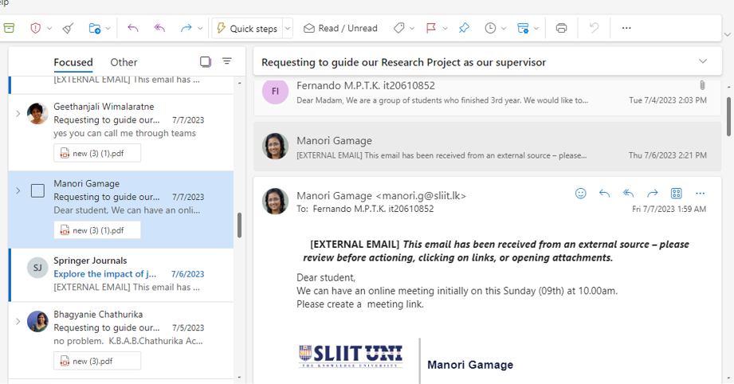

# Data Gathering and Research

# 

# 

# A screenshot of a chat Description automatically generatedMS Teams Group Creation and continuous meetings

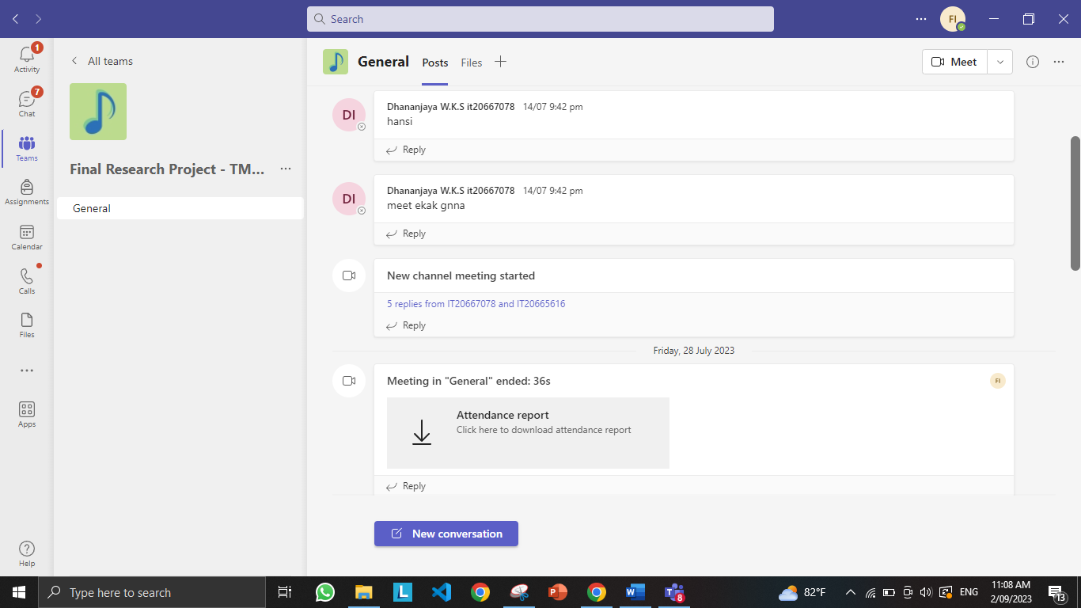

# Active with a OneDrive (Cloud) Folder for easy collaboration

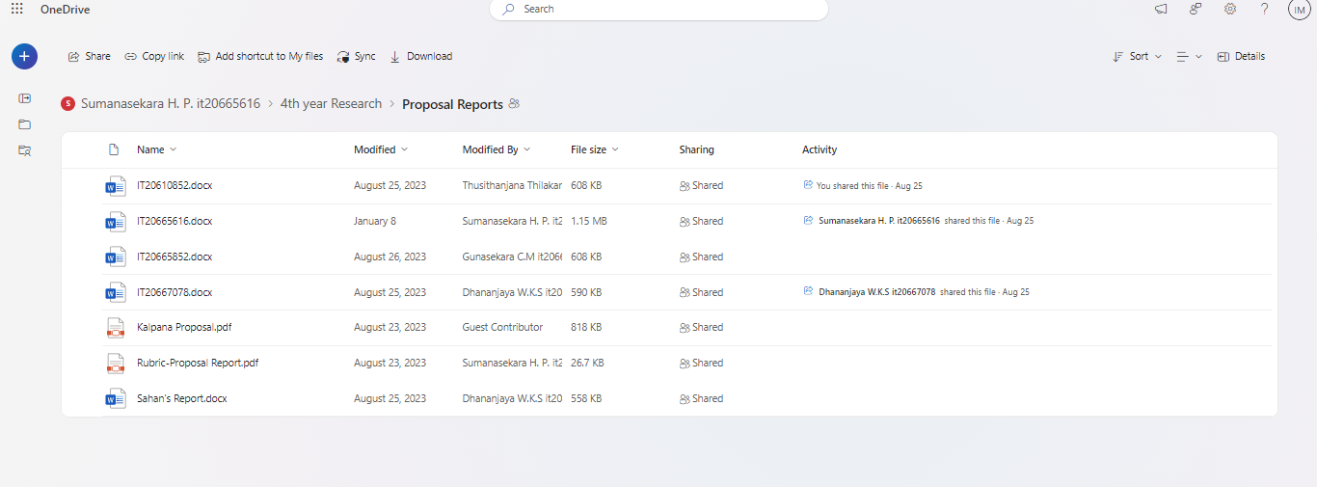

# Active with a WhatsApp Group for the Team collaboration

# 

# Maintaining a logbook

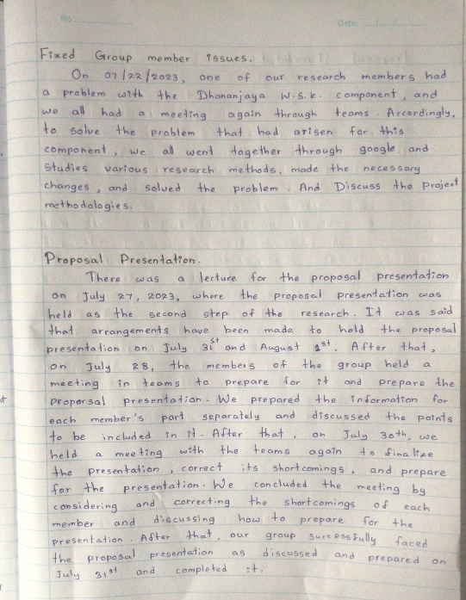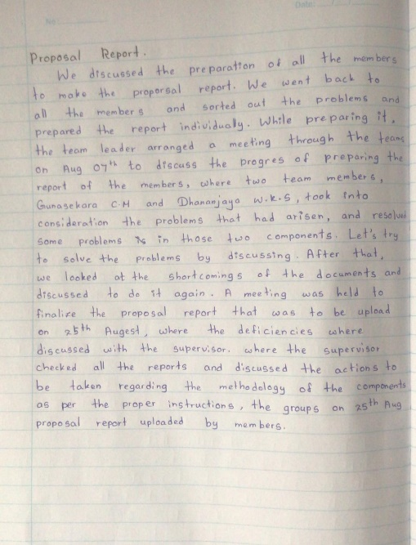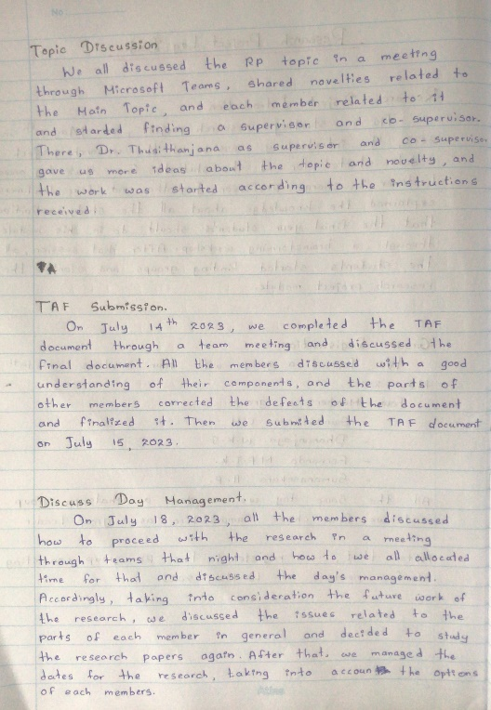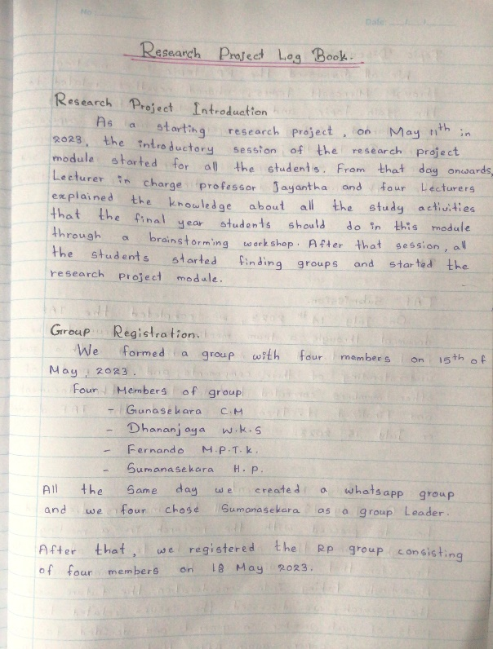

# Progress so far….

